Exam 1: R code and results

frog1 <- read.csv('frog1.csv', as.is=T)

## BoxPlots

boxplot(count ~ year, data = frog1, xlab='Year', ylab='Count', main='')

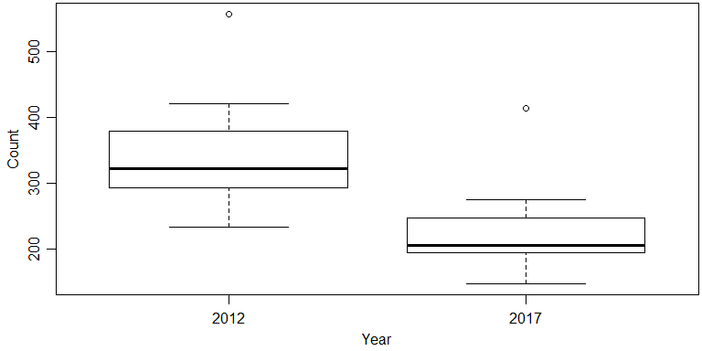

### Summary statistics

#### Number of observations in each group

#### Then averages for each group

#### and standard deviations for each group

table(frog1$year)

##   
## 2012 2017   
## 15 15

tapply(frog1$count, frog1$year, mean)

## 2012 2017   
## 339.6000 227.6667

tapply(frog1$count, frog1$year, sd)

## 2012 2017   
## 81.31842 62.57643

### T-test

t.test(count~year, data=frog1, var.equal=T)

##   
## Two Sample t-test  
##   
## data: count by year  
## t = 4.225, df = 28, p-value = 0.0002293  
## alternative hypothesis: true difference in means is not equal to 0  
## 95 percent confidence interval:  
## 57.66409 166.20258  
## sample estimates:  
## mean in group 2012 mean in group 2017   
## 339.6000 227.6667

### Wilcoxon rank sum test

wilcox.test(count~year, data=frog1, correct=F)

##   
## Wilcoxon rank sum test  
##   
## data: count by year  
## W = 201, p-value = 8.979e-05  
## alternative hypothesis: true location shift is not equal to 0

### Normal QQ plots

qqnorm(frog1$count[frog1$year==2012], xlab='2012 count', main='')  
qqline(frog1$count[frog1$year==2012])  
qqnorm(frog1$count[frog1$year==2017], xlab='2017 count', main='')  
qqline(frog1$count[frog1$year==2017])

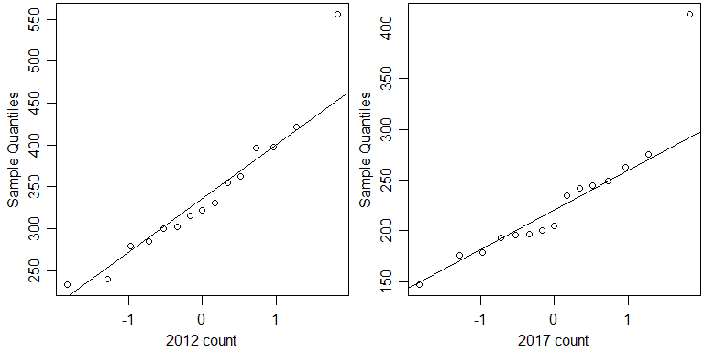

### Paired t-test, with summary statistics

Difference calculated as 2017 count – 2012 count

frog2 <- read.csv('frog2.csv', as.is=T)

frog2$diff <- frog2$N2017 - frog2$N2012

#OR:

frog2 <- frog2 %>%

mutate(

diff = N2017 – N2012)

t.test(frog2$diff)

##   
## One Sample t-test  
##   
## data: frog2$diff  
## t = -14.719, df = 14, p-value = 6.536e-10  
## alternative hypothesis: true mean is not equal to 0  
## 95 percent confidence interval:  
## -128.24401 -95.62265  
## sample estimates:  
## mean of x   
## -111.9333

mean(frog2$diff)

## [1] -111.9333

sd(frog2$diff)

## [1] 29.45327

### Normal QQ plot of the difference

qqnorm(frog2$diff, xlab='Difference', main='')  
qqline(frog2$diff)

